Bumanglag, Angeline D. BSCS-C203

Mangalino, Chriselle C. 10/01/2025

Midterm Lab Task 6 (Constructor Activity)

PROBLEM # 2

CLASS – STUDENT:

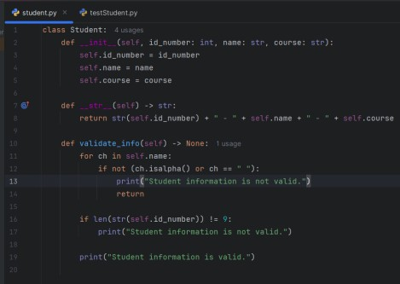

TEST CLASS:

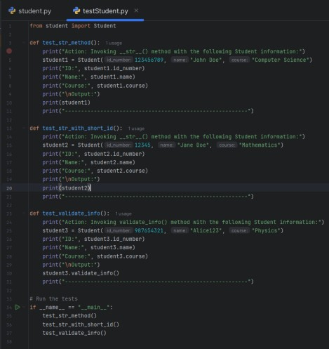

OUTPUT:

